

West Lothian Carers Strategy
Annual Report
2023-2024







Supporting people who care for others

Contents

Foreword 3
Introduction 4
Vision and Priorities 5
West Lothian Population 6.
Key Priority 1: Recognising, Valuing and Involving Carers 7
Key Priority 2: Health and Social Care Support 9
Key priority 3: Social and Financial Inclusion 12
Key Priority 4: Young Carers 14
Conclusion 16



Foreword



Alison White
Director of West Lothian Health and Social Care Partnership

West Lothian Health and Social Care Partnership recognises the role of unpaid carers and their pivotal position as equal partners in care. Carers have a unique role in the life of the person they care for.

It is positive in this annual report to see evidence of carers, the person they care for, workers from health and social care and the voluntary sector all work together as partners in care to achieve better outcomes for all involved.

I want to extend my thanks, recognition and appreciation to the unpaid carers in West Lothian who continue to play such a vital role in supporting others in our communities. I look forward to our continued work together to strengthen our services and support to carers.

Ann Pike

Carer Representative, Integration Joint Board

As the Unpaid Carer Representative, I am delighted to support the Annual Report of our Carers Strategy 2023-2026 priorities and outcomes. This report is a demonstration of the growing recognition and importance of supporting unpaid carers in West Lothian and the benefits gained not only by the carer but also by the cared for person, improving health, well-being and general quality of life.

Unpaid carers play an invaluable role in our society, often sacrificing their own needs to provide essential support to loved ones. This report highlights the critical importance of helping individuals recognise their contributions and the profound positive impact they have on our community.
Our Carer Strategy 2023-2026 focuses on ensuring that unpaid carers feel valued and supported. We are committed to providing accessible resources, practical assistance, and emotional support to help unpaid carers in their caregiving journey.
I am encouraged by the progress we've made and the continued emphasis on supporting unpaid carers. Together, we will strive to create an environment where all carers are acknowledged, supported, and empowered.
I thank everyone involved in these plans for their dedication and hard work. The contributions to the success of this plan are the cornerstone of our community's well-being.



Introduction

Welcome to the first West Lothian Carers Strategy Annual Report 2023–2024. This Annual Report reflects the work and progress of the Carers Strategy 2023-2026 key priorities and outcomes.

In West Lothian we recognise the crucial contribution that unpaid carers make to their families, friends and extended communities and are therefore committed to ensure that those undertaking an unpaid caring role, are supported to look after their own health and wellbeing, whilst also ensuring that they are not defined by their caring role.

The West Lothian Carers Strategy for 2023/26 is for all people who care for others regardless of whether or not they recognise themselves as carers. The strategy outlines the ambitions of the partnership namely that they will be supported by the local authority and health board to continue in this role through improved information, advice and support.

We recognise all carers as Equal, Expert and Valued and will continue to learn from those with lived experience, to shape our strategy and action plan. As part of this strategy, we will work with internal and external services and organisations who play an integral role in helping unpaid carers access help and support, including raising awareness of carers’ rights.
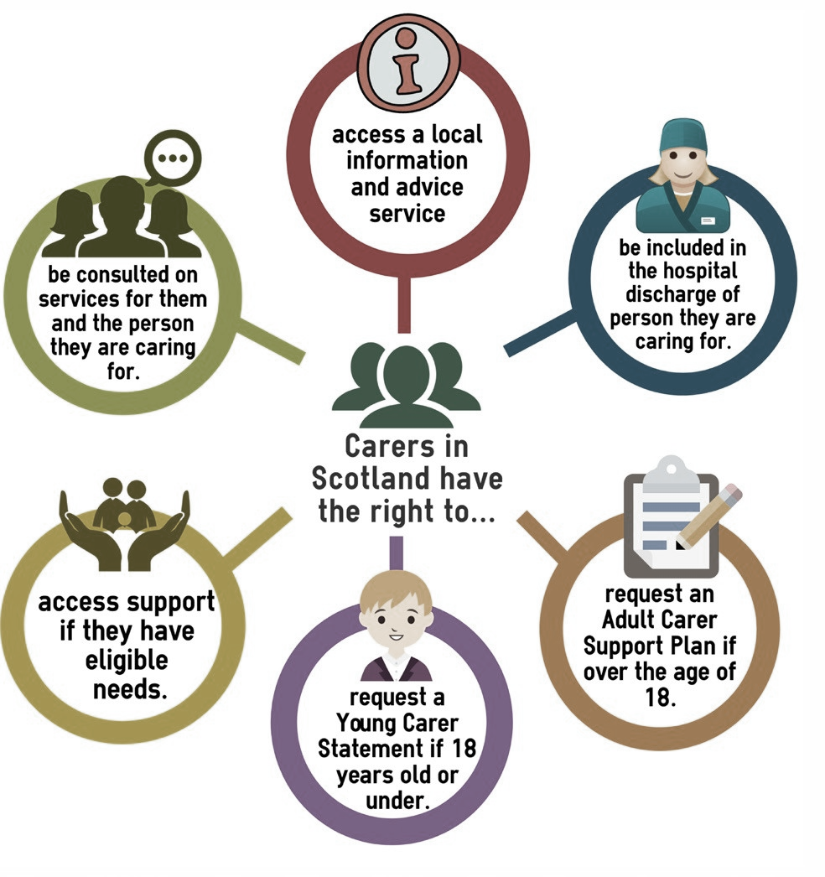

Carers rights are defined in the Carers (Scotland) Act 2016 and the purpose is to help carers continue in their caring role whilst being supported to look after their own health and wellbeing.

A multi-agency Carers Strategy Implementation Group (CSIG) has been established and has representation from relevant partners to support the progress of the West Lothian Carers Strategy Improvement Plan. This report provides an update on the progress made throughout the year in delivering the strategic objectives, and presents key data related to key performance indicators.

Vision & Priorities

Carers are valued as equal and expert partners in care and that they are supported to manage their caring responsibilities with confidence

Carers remain in good health and have a life of their own outside their caring role.

This annual report describes how the vision for carers in West Lothian will be delivered by implementing the actions in the Carers Strategy Improvement Plan which focuses on four key priority areas.

West Lothian Population

Population Overview
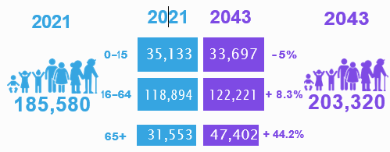
The 2021 estimates for Scotland’s population, (National Records of Scotland) show that Scotland’s overall population stands at 5.48 million people. From the same data, West Lothian has an estimated population of 185,580 which is approximately 3.4% of the overall Scottish population. By 2043 West Lothian’s population is expected to increase to 203,320 (11.6%) with the largest increase in people aged 65

Older age impacts the incidence of frailty, including dementia and other long term conditions. People with long term conditions are in general living longer all of which is expected to have an impact on demand for care and support services as well as placing greater demands on unpaid carers.
A key priority of the Carers Strategy is to support carers to look after their own health and wellbeing. This will be achieved in part by raising awareness of the support available to carers.
Scotland’s Carers – March 2024 overview
Nationally it is difficult to quantify the number of unpaid carers living in Scotland, In the latest Scottish Health Survey it is estimated that there are 696,000 people undertaking a caring role.

For West Lothian it is therefore estimated that there could be up to 23,664 people undertaken an unpaid caring role.
Scotland
Estimate

The estimated number of unpaid carers in West Lothian based on 3.4% of the population is:

West Lothian
Estimate

Key Priority 1

Key Priority 1:

Recognising, Valuing and Involving Carers
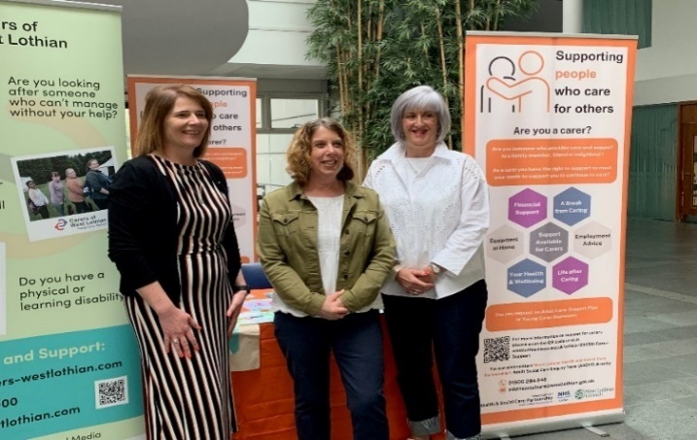

To support the work in this area the revised Carers Strategy 2023-2026 was launched during Carers Week 2023 with an event in the Civic Centre reception area on Monday 6th June 2023 followed by further public events throughout the week. Staff from the Health and Social Care Partnership (HSCP) and Carers of West Lothian (CoWL) held information stands throughout West Lothian, promoting the support available to unpaid carers.

Recognising, valuing and involving carers is crucial to ensuring that the priorities of the strategic plan are embedded in service delivery and carers are receiving the information, care and support that they need in the right format and place that is best for them.

People with lived experience of caring are represented at national and local forums by the carer representative of the IJB, the West Lothian Carer Lead and members of the Carer Strategy Implementation Group. Carers also have a voice at the Carers Voice Group meetings organised and hosted by CoWL. The opinions and needs expressed from unpaid carers is fundamental in shaping local policy and strategies including the IJB strategic Plan and the Carers Strategy.

To support the information and advice available to carers, work was progressed to having a dedicated carers page on the West Lothian Health and Social Care Partnership web site, supporting carers to navigate how to access support for themselves and their cared for person(s). Carers with lived experience have been key contributors to the development of this page and will continue to do so.
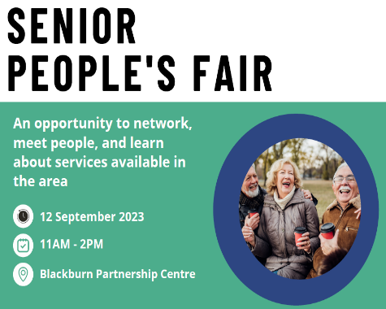
In September 2023 the HSCP organised a Senior People’s Fair. This is an annual event, where senior members of the community can be consulted, engaged and involved in decisions regarding the development of services for older people in West Lothian.

Representatives from the Carers Strategy Implementation group were in attendance providing information and support to unpaid carers.
The need for short breaks was highlighted as a key priority for those in attendance and this is reflected in the improvement plan and is a key priority to continue to develop in the period 2024/25.

Community Connections, information and advice hubs operate in key locations across West Lothian and provide the opportunity for people to access support at an early stage with the aim of avoiding crisis wherever possible. This includes support for those undertaking a caring role.

In August 2023 two carers were given the opportunity to attend the West Lothian Integration Health and Social Care Board to share their own personal experiences of caring for someone. It was really well received.

The development of key performance indicators (KPIs) is crucial to mapping the progress of the actions of the carers strategy and KPIs have been agreed to support identifying areas of strength alongside areas for improvement / development. Over this reporting period the data has shown a progressive increase in the number of Adult Carer Support Plans (ACSP) and Young Carer Statements (YCS) being offered and completed. This reflects the campaign of raising awareness of the benefits of completing one. The number of carers of older people who have an ACSP has also increased.

Data drawn from the biennial Scottish Health and Care Experience (HACE) Survey shows that the percentage of carers who feel supported to continue in their caring role has decreased over the past three years and remains low. The most current data available is for the period 2021/22 at 25.24%. The CSIG is currently in the process of developing its own survey as a way of collating more feedback on how carers feel supported. This will be reported on in the next annual report.
Carers of West Lothian (COWL) is commissioned by West Lothian Council to provide Independent Advice, Information and Support Service to Carers and people with disabilities in West Lothian. Data from CoWL for the period 2023/24 shows that they supported a total of 2,815 carers of which 392 were young carers.

This included 72 people completing counselling support, 111 people supported through the mental health and wellbeing project including 8 people receiving crisis support.

At the end of the 2023/24 period there were 7,059 adult carers and 418 young carers registered with CoWL.

To support staff and professionals to recognise a person who has caring responsibilities and how to initiate what can often be a difficult conversation, COWL delivered 66 training sessions to 313 professionals.

Key Areas for Development for 2024/25
Continue to develop key performance data particularly in relation to how well unpaid carers feel supported and using this information to support the delivery of key services

Continue to Raise awareness of carers rights ensuring that information is accessible

Key Priority 2

Key Priority 2: Health and Social Care Support

The Carers Strategy for 2020-2023 recognised that further work was required in relation to ensuring that all that undertook a caring role were aware of their right to have an Adult Carer Support Plan or if they were under 18 a Young Carers Statement. This remains a key priority area for the Carers Strategy for 2023-26.

Using Carers Strategy funding the Health and Social Care Partnership recruited three Community Care Coordinator’s (CCOs) and one Family Support Worker to support in the progress of this key priority area. Previously Adult Carer Support Plans were offered at the point of the individual having their assessment completed, at a time when most unpaid carers were not in a position to consider their own needs. By having dedicated workers, carers have been afforded the time to fully consider the impact that their caring responsibilities has on them. Carers workers are based in teams where all assessment and care management tasks are progressed which ensures that at a time when carers feel ready to consider their own needs the worker can meet with them.

The change of this approach has seen an increase in the number of Adult Carer Support Plans being completed increasing by 46% over this reporting period. Whilst the number of Young Carer Statements remains low there has been a significant increase in the number of completed assessments form 2 being completed in 2022/23 increasing to 13 in 2023/24.

For carers who have completed an ACSP or YCS and meet the local eligibility criteria they can receive a Self-Directed Support (SDS) budget to meet their agreed personal outcomes and needs. The number of carers receiving an SDS budget has increased by 58% since 2020/21.

An outcome of the carers strategy is to promote and imbed the flexible use of SDS budgets to meet the carers personal health and wellbeing outcomes.

Feedback received from carers has complimented the flexible and innovative use of SDS budgets. Budgets have been used to purchase short breaks, sport and hobby equipment, leisure activities for themselves and in some cases with their cared for person. Feedback from a carer:
“My Xcite membership has been really great. I’ve been going down a few times a week and it has given me time to myself to (prioritise) my own physical and mental health. It’s given me a welcome break from my caring role. I know my daughter is safe so I am enjoying it more due to the fact I can relax. I’m going to add another day of swimming and start taking her. All in all it’s been good to have a bit of ‘me’ time.”

In addition to SDS budgets to support breaks from caring, Short Breaks have been made available to carers and their cared for person through Scottish Government funding made available directly to Carers of West Lothian and through the Carers Strategy funding.

Carers of West Lothian received funding from Shared Care Scotland which was given out in Time to Live grants. The value of the funding was £83,690 and benefited 234 carers which is an average grant of £350 per carer. What the grants have meant to people:

Having a space to call my own where I can relax and enjoy the great outdoors has improved my own mental health no end. Just being able to relax and unwind is priceless. Before my grant the garden was a mess and depressed me, I had nowhere to de-stress, which is so important I now have my own wee haven and I can't thank you guys enough

Receiving the grant gave my wife and I the opportunity to go away for a relaxing, stress free and enjoyable break. We spent quality time as husband and wife which is precious to us instead of being carer and cared for. We made lovely memories on this break. Without this grant, this would not be possible.

In 2022, the IJB agreed to use one-off £70,000 funding to support local organisations coming out of lockdown. The first round of £40,000 funding was extremely successful with 978 carers and their cared for person benefitting from the funding activities. The second round ran From April 2023 – August 2023. It was aimed at grass roots community groups, small charities, social enterprises, 3rd sector and voluntary organisations who bid in to proactively find innovative ways to encourage carers (and their cared for person if appropriate) to engage in short breaks or activities to support their health and wellbeing. Funding between £1k - £5k was available to fund this support to carers. Ten organisations received funding to a total of £30,000.
The ten organisations who received funding in the second round of the funding to support unpaid carers in West Lothian were

A total of 980 carers and their cared for person(s) benefited from the support from the organisations

Feedback from three of the organisations on the impact of the funding includes:

This has been a fantastic opportunity for us to positively engage with unpaid carers in our community and it has given us the opportunity to actively get them involved with our group and signpost to other services we provide such as community larder or Young at Heart events. We have built up a connection with the group meaning they find it easier now to come along to other things with us and has created a group with friendship and support.
The funding has made a huge difference to our organisation. We have consistently struggled to engage with carers, they are a very hard to reach community of interest. There are many reasons for this. Many don't actually feel that they are carers. For example, if providing care for a relative of loved one they often don't see this as "caring", they see it as something they "just do" because they care. The funding enabled us to widely promote and advertise the activities and projects on offer. We held a large event for those who provide care in the community. over 50 people attended. This was a record number, no other organisation has managed to engage with this group in Fauldhouse. We also provided therapy sessions and arts and crafts sessions for children and young people. We provided vouchers for family treats, and we made sure every carer knew they were valued, and they are an important part of their community. We also prepared a contact data base, and we are now in the process of following up with those who participated to put some of the ideas that were generated via our interaction with the carers and those cared for.
It is difficult for South Asian communities to identify themselves as carers and seek support in order to prevent deterioration to their own help due to the demanding caring responsibilities. Through the links we have already in West Lothian it was beneficial to reach out to people and build trusted relationships within our community of interest in West Lothian.

Over the course of this reporting period the Assessment and Review team have trailed the use of FORT (Fast Online Referral Tracking) system. This is a system used within West Lothian Council, to provide a streamline online referral process to over 40 third sector organisations. In utilising this online system, it has improved and simplified the customers journey to accessing the support they need in a timely manner. Feedback has been very positive and staff report that by using FORT, a number of referrals can be made at the one time, allowing effective time management and, by having the function to check progress, service users can be kept up to date to reduce anxieties.

A key aim of the strategy is to expand the use of technology to support the carer and the cared for person to remain living safely and independently at home. Collaborative working has been established with the Technology Enabled Care (TEC) team. Systems such as KOMP have supported carer’s to maintain contact with their cared for person through a video link. The expansion of TEC and digital solutions will continue to form part of the work of the Carers Strategy Implementation Group.

Carers of West Lothian are a key partner in the delivery of the strategy. Alongside the core funding they receive from the West Lothian Health and Social Care Partnership, Carers of West Lothian have also been successful in securing additional funding to support specific one-off projects to support with some of the key priorities of the strategy, this will include Strengthening healthcare links: (Funded for 3 years by Lottery Improving Lives) a project which will aim to reach carers earlier through the establishment of connections with community Health Centres. This project launch in February 2024 with regular updates being provided to make progress

Another new initiative is the Memory Information Support Team (MIST) (Funded by NHS Health Improvement Fund for 3 years), this project which launched in March 2024 is a collaboration with Cyrenians, OPAL, West Lothian Food Train, Generation Arts and NHS Lothian’s Memory Treatment Service. The project aims to support carers and cared for person with memory difficulties, whilst waiting for a formal diagnosis.

Key Areas for Development for 2024/25

To continue to promote the benefits of having an Adult Carer Support Plan and Young Carers Statement

Continue to support the workforce in relation to Self-Directed Support particularly in ensuring any unpaid carer has choice and control over the delivery of their support

To further develop and strengthen opportunities for short breaks and breaks from caring through the revision of the Short Breaks Statement

To launch a targeted campaign to reach older carers including promoting POA




Key Priority 3

Key priority 3: Social and Financial Inclusion

The West Lothian Council’s Anti-Poverty Service, Advice Shop is a key partner in the Carer Strategy Implementation Group and offers support in many different areas including, welfare benefits, money and debt advice, housing and energy advice.

In October 2023 Carers UK published ‘State of Caring in Scotland – The financial impact of caring in 2023’, This provides a national context on the financial hardship that unpaid carers in Scotland can experience. The report details that those who are in receipt of Carer Support Payment (formally known as Carer’s Allowance), the main benefit for unpaid carers, have been disproportionately impacted by rising prices and the cost-of-living crisis. The report continued that a significant proportion of carers were falling into debt and arrears as a result. Some Findings from the survey undertaken found that:

- More than a quarter of carers (28%) and 41% of carers on Carer’s Allowance are struggling to make ends meet

- 44% of carers on Carer’s Allowance are cutting back on food and heating

- One in six carers on Carer’s Allowance are visiting foodbanks

A local snap shot at November 2023 suggests there were 3,234 claimants of Carer Support Payment, which is an increase of 191 from November 2020.
Over the coming period it remains of great importance of the Carers Strategy Implementation Group to ensure that those undertaking a caring role have their income maximised and will continue to work with the Anti Poverty service on this key area.

The Anti-Poverty service offers a fortnightly drop in service at Carers of West Lothian in Livingston as well as weekly drop-in sessions at the Jim Walker Partnership Centre, Bathgate, and outreach sessions in a number of locations across West Lothian. In the period 2023/24 the total annual amount of additional income generated for carers and their families through this activity was £832,626. The graph shows a quarterly increase in income maximised for carers and their families and reflects the awareness raising of the financial supports available for carers and their families.

Along with the financial gains the Advice Shop also achieved non-financial outcomes for carers and their families which included blue badge awards, prevention of disconnection from utility companies, supply reconnection, accessing the NHS Low Income scheme and accessing Xcite swimming vouchers.

Targeted national and local awareness raising initiatives have been run to increase the awareness of the benefits of having Power of Attorney for the cared for person and also what financial and social supports are available for carers and their cared for person. National days have been utilised to run social media awareness raising of supports including: Carers Week, Young Carers Action Day and Power of Attorney Day.

During the period Power of Attorney Day campaign, COWL’s in partnership with a local solicitor offered PoA sessions at a discounted price with 112 carers accessing this support.

It is well recognised that carers can face additional strains when they are employed including organising time off to support their cared for person at medical appointments etc. or having to reduce their working hours or cease employment altogether which causes additional financial pressures.

A key outcome for the strategy is to work with employers across West Lothian and Carer Positive Scotland to become a Carer Positive Employer. To achieve this, employers are required to undertake a self-assessment to demonstrate how the meet the key components of each of the award levels.

Over the course of this reporting period Voluntary Sector Gateway and West Lothian College both achieved level 1 accreditation. This is a great accomplishment and shows the dedication to fostering a workplace culture that is supportive, inclusive, and compassionate towards carers.

Key Areas for Development for 2024/25

To launch a number of campaigns throughout the year specifically in areas where we have identified large areas of individuals who are undertaking an unpaid caring role.

To work with local employers around Carer Positive awards and where appropriate support with the self-evaluation process





Key Priority 4

Key Priority 4: Young Carers

Many young carers do not recognise themselves as carers as their caring role is such an integrated part of their lives. Their caring role can be very isolating, worrying and stressful. In West Lothian it is recognised that we can and must do more to identify and support young carers and therefore it is one of our priority areas.

West Lothian Children’s Rights Group and Network supports and encourages participation of young people in matters that are important to them and to have their voices heard. This group is tasked with considering the rights of young cares and ensuring their voices and experiences are recognised and considered going forward in areas that matter to them.

The recruitment of the Family Support Worker (FSW) focusing on Young Carer Statements (YCS) has had positive impact for young people and their families, with many advising that they have felt well supported and listened to. There have been improvements in the referral process for Young Carers Statements supporting both self-referrals and professional referrals.
Over this period there has been a significant increase in the volume of requests for a Young Carers Statement.

A Young Carers working group has been established during this year with representation from Social Policy, Education and Carers of West Lothian. The group initiated working with schools to create and launch bite sized powerpoint modules covering the topics:
- “What is a Young Carer?”,
- “Identifying Young Carers”,
- “Support for Young Carers in West Lothian”, and
- “Impact of being a Young Carer”.
The purpose of this was to create accessible training sessions for all education staff to access.

Another new development for this year has been the rollout of Young Carer Champions across all 13 secondary schools in West Lothian. The Young Carers Champions regularly update the members of the working group.

The Young Carers worker also have access to a Glow account and is able to use this to send information out to Young Carer Champions via this alongside the establishment of an MS Team’s channels in some of the schools to use as a platform to share up and coming events or relevant information as well being a way for young people themselves to seek advice and support.

Whilst digital options are being fully utilised Carers of West Lothian also co-ordinate and facilitate Young Carers groups within 11 Secondary Schools in West Lothian.

Over this reporting period there have been various events organised to support young carers to have a break from their caring role and meet other young carers.

This includes Child Disability Service and Carers of West Lothian establishing a Young Carers group, for siblings of children with disabilities and additional support needs. The group provides participants the opportunity to have fun with other young people who understand their circumstances. All Young Carers
who attend the group are also be offered a Young Carers Statement. Two successful groups have taken place, with 12 Young Carers attending each session. Activities have included ice breaker bingo, pancake decorating and decorating family trees. Groups have also been used to inform consultation has taken place to inform future activities and trips. Feedback has been positive, with Young Carers expressing they have ‘enjoyed meeting other sibling young carers’ and have ‘made new friends’. Parents have also expressed positive feedback.
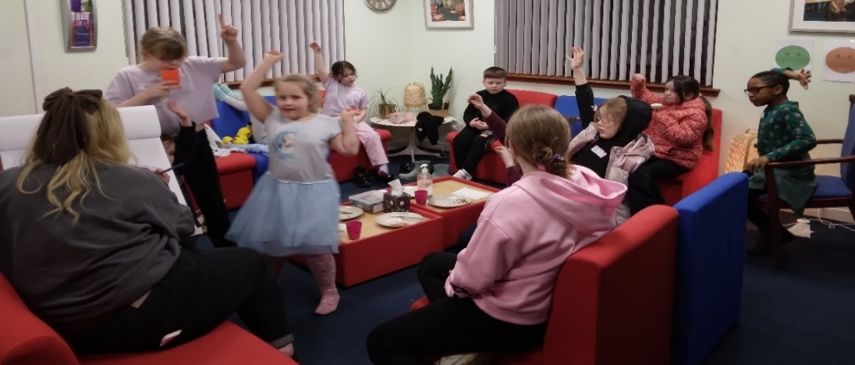

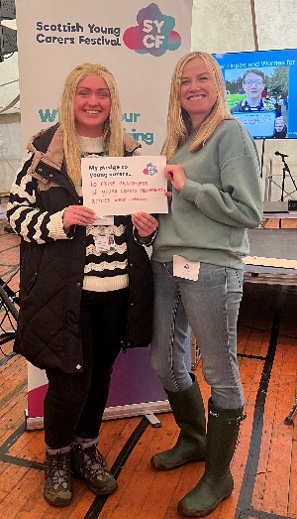

The Scottish Young Carers Festival takes place every year and provides a chance for Young Carers to have a break from their caring role, meet other young carers, take part in consultation and try new activities. The festival is a 3 day, 2 night camping experience for Young Carers age 11 – 18. 25 young carers form West Lothian attended the festival and enjoyed participating in a range of activities such as waterslides, Thera Pet sessions, Live Music and a silent disco. Staff from the Child Disability Service and COWL attended the event to support those attending.

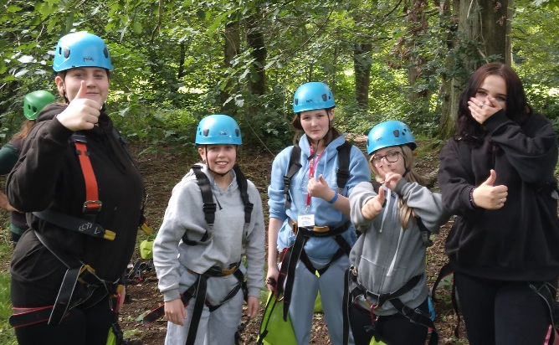

With summer program funding, COWL ran four weeks of activities for young carers to enjoy a break from the caring responsibilities during the summer school break. These included the festival, a visit to an alpaca farm, a barge trip and all some parent in the park meets for parent carers, young carers and siblings

62 young carers attended the activities

Key Areas for Development for 2024/25

Work with Education Services will develop links with the Health & Wellbeing champions in Primary schools ensuring that the role of Young Carers is understood and supported

To continue to promote the benefits of having an Adult Carer Support Plan and Young Carers Statement
Conclusion

Carers play a vital role in society and there is a long history in West Lothian of working in partnership with unpaid carers. It is important that carers are aware of the support available to them to support them in their caring roles to stay in good health themselves.

This annual report looks to highlight the key achievements of the work that has been progressed in the first year of the West Lothian Carers Strategy for 2023/26 and whilst this work does not sit in isolation there continues to be a commitment to ensure that all those that are undertaking an unpaid caring role have the right support at the right time.

Members of the Carers Strategy Implementation Group have identified a number of key priority areas for the coming year whilst also continue to build on the successes of the previous year.

Supporting people who care for others

Scottish Government’s Scottish Health Survey and the 2021 mid-year population estimates published by National Records of Scotland which produced the figures below
Mid-year population estimates for Scotland in 2022 | National Records of Scotland (nrscotland.gov.uk)

